

**Prescription Monitoring Program Information Exchange (PMIX)**

**IEPD Master Documentation  
Version 0.1.0**

**September 2012**

**TABLE OF CONTENTS**

1. Introduction 4

2. PMIX Purpose and Business Requirement 5

3. PMIX Data Model: Non-Normative Recommendations 6

a. Nillable Elements 7

b. Repeatable Elements 8

4. Appendix A — Document History 10

**TABLE OF FIGURES**

Figure 1: In-State PMP User Story 4

Figure 2: PMIX Purpose and Business Requirement 6

**TABLES**

Table 1 Nillable Elements 8

Table 2 Repeatable Elements 9

**Acknowledgements**

This document was produced as part of the BJA-sponsored IJIS Institute project in support of the Prescription Monitoring Program Information Exchange (PMIX). Major portions of this document were derived directly from the earlier PMIX Project documents and significant contributions were made by the IJIS Institute Prescription Monitoring Program (PMP) Committee and IJIS Institute member company Open Networks, Inc.

This project was supported by Grant No. 2009-PM-BX-K044 awarded by the Bureau of Justice Assistance. The Bureau of Justice Assistance is a component of the Office of Justice Programs, which also includes the Bureau of Justice Statistics, the National Institute of Justice, the Office of Juvenile Justice and Delinquency Prevention, and the Office for Victims of Crime. Points of view or opinions in this document are those of the author and do not represent the official position or policies of the United States Department of Justice.

# Introduction

The document contains the Master Documentation for the Prescription Monitoring Program Information Exchange (PMIX) National Information Exchange Model (NIEM) Information Exchange Package Documentation (IEPD). It describes the PMIX IEPD purpose and business requirement.

All states have laws and regulations that govern the distribution and handling of controlled substances and other pharmaceuticals. Diversion of, and addiction to, such substances are generally recognized as serious problems throughout the country. States have found that prescription monitoring programs (PMPs), which collect prescription-controlled-substance dispensing data from pharmacies and other authorized dispensers, can be effective tools for identifying and preventing these problems. These data are then reviewed and analyzed for medical, educational, public health and investigative purposes.

Before describing the particular business requirement for information exchanges between PMPs, it can be instructive to understand the current context in which PMP data is created and accessed within states. The figure below depicts the in-state PMP user story. In most states, most dispensers of prescription controlled substances are required to report data regarding each dispensing transaction to a state authority, which stores the associated record in a PMP database. An authorized PMP end user, typically a prescriber, can then access this data through a web browser and PMP application to review the reported dispensing history for a particular patient before writing a new prescription. In some states, dispensers or law enforcement officials may also access the data.

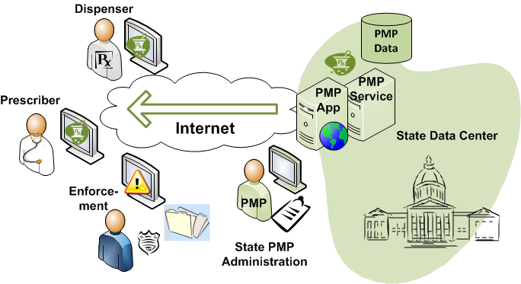

Figure : In-State PMP User Story

# PMIX Purpose and Business Requirement

Prescriptions for controlled substances are often dispensed in a different state from that of the patient’s residence or physician’s office. Many people have occasion to travel regularly to other states for work or leisure.

Prescriptions can be obtained fraudulently by individuals who have discovered that they can elude detection by crossing state borders to “shop” for unsuspecting prescribers or dispensers. These doctor shoppers often travel to multiple states to increase the quantities of controlled substances that can be diverted.

Since prescription information is reported to the PMP of the state in which the prescription is dispensed, authorized users of PMP systems in other states will have no access to this information without interstate data sharing. State officials are becoming increasingly concerned about cross-border diversion of prescription controlled substances as the abuse involving these drugs continues to escalate.

The purpose and business requirement for the PMIX IEPD is to provide a data model for the user story in which PMP end users can, via a requesting state PMP system, retrieve prescription drug histories from other state PMPs to support their decision-making.

This user story is illustrated (twice) in the figure below. The prescriber on the left would be able, using a web browser, to access both in-state (green) and out-of-state (purple) PMP records upon submission of appropriate search criteria. In the second illustration, the prescriber in the “purple” state would be able to access records from both state PMPs.

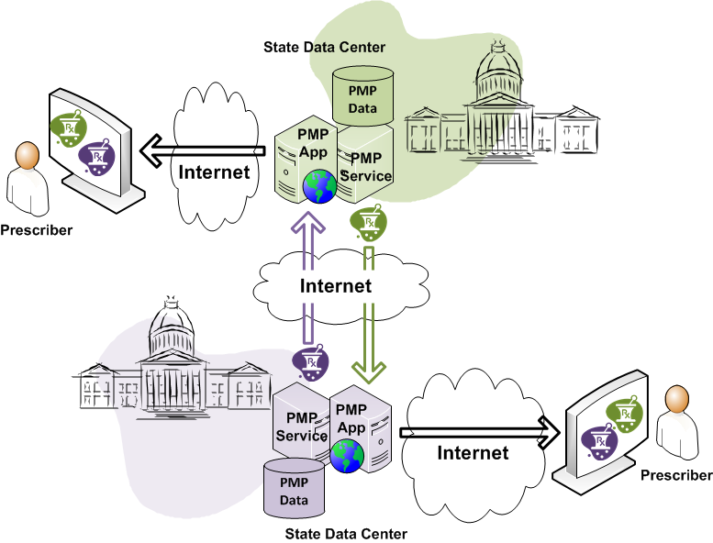

Figure : PMIX Purpose and Business Requirement

Additional requirements are that all electronic data flows between PMPs take place over the Internet and that any data contained therein remain secure, including strict confidentiality of patient protected health information and other identifying information, while in transit between sending and receiving endpoints.

There is no requirement, however, that the transmission occur directly between PMP systems. One or more intermediary servers are allowable provided that the end-to-end confidentiality requirement is met.

# PMIX Data Model: Non-Normative Recommendations

The IEPD in this first version of the PMIX specifications generally includes loose normative constraints to afford each participant pair wide latitude in choosing which particular elements meets exchange requirements. However, it is hoped that common exchange decisions will soon emerge and increase the level of reuse in the national community.

Toward this end, the following **non-normative** recommendations are intended to provide initial guidance in helping to shape a stronger set of schema-based normative constraints to appear in future versions of the PMIX IEPD. In particular, these recommendations can optionally be applied to XML instances under the “*PMIX NIEM 2.0 PMP Prescription Report*” and “*PMIX NIEM 2.0 Request Schema*” exchange schemas.

The keywords used in the following conformance statements should be interpreted as follows:

* SHALL/SHALL NOT: an absolute requirement/prohibition;
* SHOULD/SHOULD NOT: a best practice or recommendation; there may be valid reasons to ignore an item, but the full implications must be understood and carefully weighed before choosing a different course;
* MAY/NEED NOT: truly optional; recommendation can be followed or not with no implications.

The following conformance statements represent **non-normative** recommendations that can optionally be adopted as constraints on valid instances under the “*PMIX NIEM 2.0 Request Schema*” (for requests) or the “*PMIX NIEM 2.0 PMP Prescription Report*” schema (for responses).

# Nillable Elements

Although a particular element defined in the extension schema “*PMP_NIEM_2.0_Domain_Extension_Schema*” may have an attribute **nillable**=”true”, each instance of this element arising from either the request or response exchange schema **SHOULD** generally avoid loading a null value **UNLESS** the exchange participants expressly agree otherwise.

As a convenient reference, the extension schema elements that have this attribute are enumerated below:

|  |  |
| --- | --- |
| ReportDateRangeBegin | ReportDateRangeEnd |
| RequestPrescriptionDateRangeBegin | RequestPrescriptionDateRangeEnd |
| ChainSiteIDText | CompoundDrugIngredientDEAClassScheduleText |
| CompoundDrugIngredientDrugDosageUnitsCode | CompoundDrugIngredientProductNameText |
| CompoundDrugIngredientSequenceNumber | CompoundDrugIngredientStrengthText |
| ContactNameText | DaysSupplyCount |
| DEAClassScheduleText | DEANumberIdentifier |
| DispensedQuantity | DrugDosageUnitsCode |
| DrugProductNameText | DrugRefillNumberCount |
| DrugStrengthText | DrugUnitOfMeasureText |
| DocumentPublicationTime | InformationSourceEntityNameText |
| IngredientQuantity | MessageText |
| MethodOfPaymentCode | NCPDPIdentifier |
| NPIIdentifier | PartialFillIndicator |
| PatientLocationCode | PatientNameOfAnimalText |
| PrescriberDEANumberSuffixText | PrescriptionElectronicReferenceNumberText |
| PrescriptionFilledDate | PrescriptionNormCodeText |
| PrescriptionNumberText | PrescriptionSoldDate |
| PrescriptionWrittenDate | RefillsAuthorizedCount |
| ReportExecutionDate | ReportExecutionTime |
| ResponseIDText | RoutingNumber |
| SpeciesCode | StateIssuedRxSerialNumberIdentifier |
| StateLicenseIdentifier | TransactionControlNumberText |
| TransmissionFormOfRxOriginCode | UniqueInformationSourceIDText |
| VersionReleaseNumberText | PMPPresentationDocument |
| RequestPatient | CompoundDrugIngredient |
| PrescriptionDrug | Dispenser |
| RequestDispenser | Pharmacist |
| Prescriber | RequestPrescriber |
| Prescription | PrescriptionForReporting |
| ReportDateRange | RequestPrescriptionDateRange |

Table Nillable Elements

# Repeatable Elements

Although a particular element defined in the extension schema “*PMP_NIEM_2.0_Domain_Extension_Schema*” may have an attribute **maxOccurs**=”unbounded”, **EXCEPT** for the Prescription element, each other element instance arising from the response exchange schema **SHOULD** avoid being repeated (appearing at most once) **UNLESS** the exchange participants expressly agree otherwise.

As a convenient reference, the extension schema elements (aside from Prescription) that have the **maxOccurs**=”unbounded” attribute are enumerated below:

|  |  |
| --- | --- |
| PersonPrimaryContactInformation | DocumentPublicationTime |
| CompoundDrugIngredientProductIdentifier | CompoundDrugIngredientSequenceNumber |
| CompoundDrugIngredientStrengthText | CompoundDrugIngredientProductNameText |
| IngredientQuantity | CompoundDrugIngredientDEAClassScheduleText |
| DrugProductNameText | CompoundDrugIngredientDrugDosageUnitsCode |
| DrugUnitOfMeasureText | DrugStrengthText |
| CompoundDrugIngredient | DEAClassScheduleText |
| DEANumberIdentifier | NPIIdentifier |
| NCPDPIdentifier | StateLicenseIdentifier |
| ChainSiteIDText | ContactNameText |
| NPIIdentifier | PersonPrimaryContactInformation |
| PersonPrimaryContactInformation | StateLicenseIdentifier |
| DEANumberIdentifier | NPIIdentifier |
| StateLicenseIdentifier | PrescriberDEANumberSuffixText |
| PrescriptionNumberText | Dispenser |
| PrescriptionFilledDate | DrugRefillNumberCount |
| Prescriber | Patient |
| PrescriptionDrug | PrescriptionWrittenDate |
| DispensedQuantity | RefillsAuthorizedCount |
| DrugDosageUnitsCode | DaysSupplyCount |
| TransmissionFormOfRxOriginCode | MethodOfPaymentCode |
| Pharmacist | PartialFillIndicator |
| ReportingStatusCode | StateIssuedRxSerialNumberIdentifier |
| PrescriptionNormCodeText | PrescriptionSoldDate |
| VersionReleaseNumberText | PrescriptionElectronicReferenceNumberText |
| TransactionTypeCode | TransactionControlNumberText |
| ReportExecutionDate | ResponseIDText |
| FileTypeCode | ReportExecutionTime |
| UniqueInformationSourceIDText | RoutingNumber |
| MessageText | InformationSourceEntityNameText |
| ReportExecutionDate | PrescriptionForReporting |
| ReportDateRange | ReportExecutionTime |

Table Repeatable Elements

It is anticipated that all the recommendations above will be added to the backlog as candidates for the creation of stronger constraints for the next version of the PMIX Service Specification. In the next version, these recommendations should, to the fullest extent possible, be codified as normative constraints within NIEM constraint schemas.

Note that all current **normative** constraints are embodied in the schema set. No new normative constraints have been introduced here.

# Appendix A — Document History

|  |  |  |  |
| --- | --- | --- | --- |
| Date | Version | Editor | Change |
| 10/2012 | 0.1.0 | Bob Slaski, Open Networks; Scott Serich, IJIS Institute | Initial draft, including feedback from PMIX Springboard initiative |
|  |  |  |  |